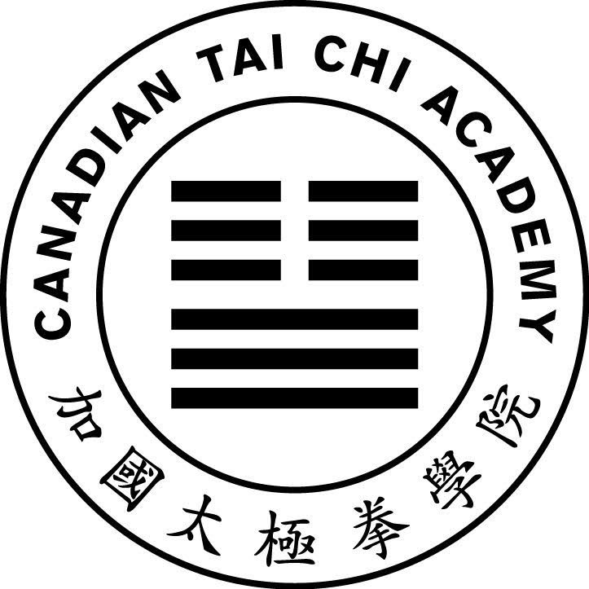
Central Region Lok Hup Ba Fa Workshop Part II
V7
Registration Form
London: June 18 to June 20, 2026

Name: ________________________________ Email: _____________________________
Location: ______________________________ Phone: ____________________________
CTCA Member: ○ Yes ATCA Member: ○ Yes Other: ○ __________________________

Lok Hup Experience: First Half (years) __________ Second Half (years) __________

Transportation (contact us if you need pickup from station/airport):
○ Own Vehicle ○ Bus / RobertQ ○ Train ○ Plane ○ Other
Date/Time Arriving: _____________________________________________ ________________
Date/Time Departing: ___________________________________________

Accommodation at Fanshawe (Please check all nights requiring accommodation):
○ Not required □ Wednesday June 17 ○ Thursday June 18 ○ Friday June 19
□ Saturday June 20 ○ Other: _______________________

Room Type (Please check one type)
○ Male Suite ○ Female Suite ○ Group of 4 (send list of roommates)

Meals (Please check all meals required at the workshop venue). All meals are served at the Oasis dining hall (at Fanshawe College).

○ Not required | Breakfast | Lunch | Dinner
Thursday June 18 | □ | □ | ○
Friday | ○ | ○ | ○
Saturday | ○ | ○ | □
Sunday | □ | □ | □

Special Diet (Please check any that apply):
○ Vegetarian ○ Gluten Free ○ Vegan ○ Other: __________________

Attending Other Workshops? ○ Central Region Instructor Training Week June 14 to June 18

More Information: www.LondonTaiChi.ca/Fanshawe2026

Questions? Fanshawe@LondonTaiChi.ca or 844-205-6944 Toll Free

