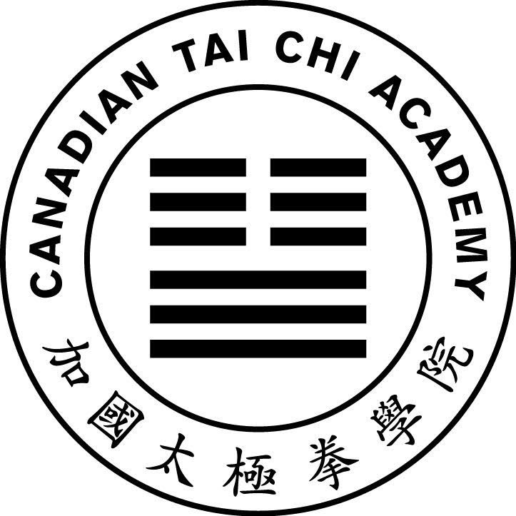
Central Region Instructor Training Week
V8
Registration Form
London: June 14 to June 18, 2026

Name: ______________________________ Email: _____________________________
Location: ____________________________ Phone: ____________________________
CTCA Member: ○ Yes ATCA Member: ○ Yes Other: ○ __________________________

Instructor: ○ Yes ○ No

Training Pledge: I am committed to supporting my location administration and instruction activities. I wish to attend to improve my personal development to support instruction. Initials: _________

Training Stream ○ Beginner ○ Continuing

Transportation (contact us if you need pickup from station/airport):
○ Own Vehicle ○ Bus / RobertQ ○ Train ○ Plane ○ Other
Date/Time Arriving: _____________________________________________ ________________
Date/Time Departing: ___________________________________________

Accommodation at Fanshawe (Please check all nights requiring accommodation):
○ Not required □ Saturday June 13 ○ Sunday June 14 ○ Monday June 15
○ Tuesday June 16 ○ Wednesday June 17 □ Thursday June 18 □ Friday June 19

Room Type (Please check one type)
○ Male Suite ○ Female Suite ○ Group of 4 (send list of roommates)

Meals (Please check all meals required at the workshop venue). All meals are served at the Oasis dining hall (at Fanshawe College).

⃝ Not required | Breakfast | Lunch | Dinner
Saturday June 13 | □ | □ | □
Sunday | ○ | ○ | ○
Monday | ○ | ○ | ○
Tuesday | ○ | ○ | ○
Wednesday | ○ | ○ | ○
Thursday | ○ | ○ | □
Friday | □ | □ | □

Special Diet (Please check any that apply):
○ Vegetarian ○ Gluten Free ○ Vegan ○ Other: __________________

Attending Other Workshops? ○ Central Region Lok Hup Ba Fa Workshop Part II – June 18 to 20

