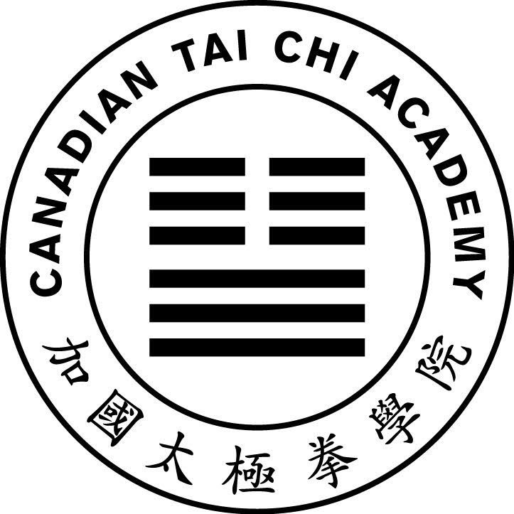
Central Region Instructor Training Week
V5
Registration Form
London: June 30 to July 4, 2025

Name: ______________________________ Email: _____________________________
Location: ____________________________ Phone: ____________________________
CTCA Member: ⃝ Yes ATCA Member: ⃝ Yes Other: ⃝ __________________________

Instructor: ⃝ Yes Instructor: ⃝ Yes

Transportation (contact us if you need pickup from station/airport):
⃝ Own Vehicle ⃝ Bus / RobertQ ⃝ Train ⃝ Plane ⃝ Other
Date/Time Arriving: _____________________________________________ ________________
Date/Time Departing: ___________________________________________

Accommodation at Fanshawe (Please check all nights requiring accommodation):
⃝ Not required ⬜ Sunday June 29 ⃝ Monday June 30 ⃝ Tuesday July 1
⃝ Wednesday July 2 ⃝ Thursday July 3 ⃝ Friday July 4 ⬜ Saturday July 5
⃝ Other: _______________________

Room Type (Please check one type)
⃝ Male Suite ⃝ Female Suite ⃝ Group of 4 (send list of roommates)

Meals (Please check all meals required at the workshop venue). All meals are served at the Oasis dining hall (at Fanshawe College).

⃝ Not required | Breakfast | Lunch | Dinner
Sunday June 29 | ⬜ | ⬜ | ⬜
Monday | ⃝ | ⃝ | ⃝
Tuesday July 1 | ⃝ | ⃝ | ⃝
Wednesday | ⃝ | ⃝ | ⃝
Thursday | ⃝ | ⃝ | ⃝
Friday | ⃝ | ⃝ | ⃝
Saturday | ⬜ | ⬜ | ⬜

Special Diet (Please check any that apply):
⃝ Vegetarian ⃝ Gluten Free ⃝ Vegan ⃝ Other: __________________

Attending Other Workshops? ⃝ Western Central Region General Tai Chi Workshop June 28 to 29
⃝ Western Central Region Lok Hup Ba Fa Workshop July 5 to 6

